How to switch touch device driver
1. Decompress the zip file.
2. Click the “DriverPatch.exe”
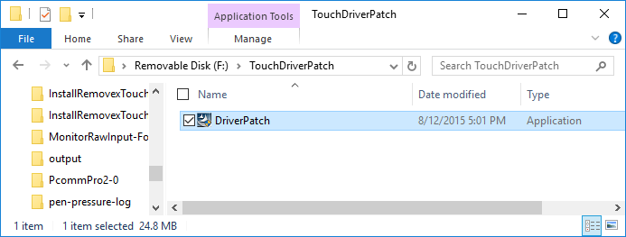
3. Please click “Yes “ button , if the “User Account Control” dialog is pop-up.
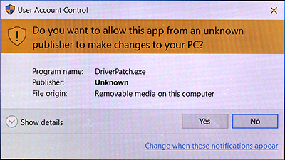
4. If your system has touch device that installed with eGalaxTouch driver, you will see a message like the below picture. And the tool starts to switch touch device with inbox (native) driver.
If success, the window will close automatically.
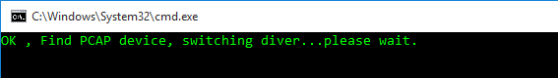
If the tool cannot find the EETI touch device with eGalaxTouch driver or the Windows is not Windows 10, you will see an error message like below picture.
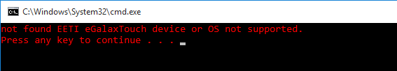
After apply the new driver, the mulit-touch device should work correctly.
If you encounter any problem, please contact touch_fae@eeti.com for supporting.

